Part I: XML Architecture & Querying (Operations Team)

Queries:
- Flowers that bloom in Summer
Code:
for $f in //Flower
where contains($f/seasons, "Summer")
return <Result>
<flowerId>{$f/flowerId/text()}</flowerId>
<name>{$f/name/text()}</name>
</Result>
Screenshot:
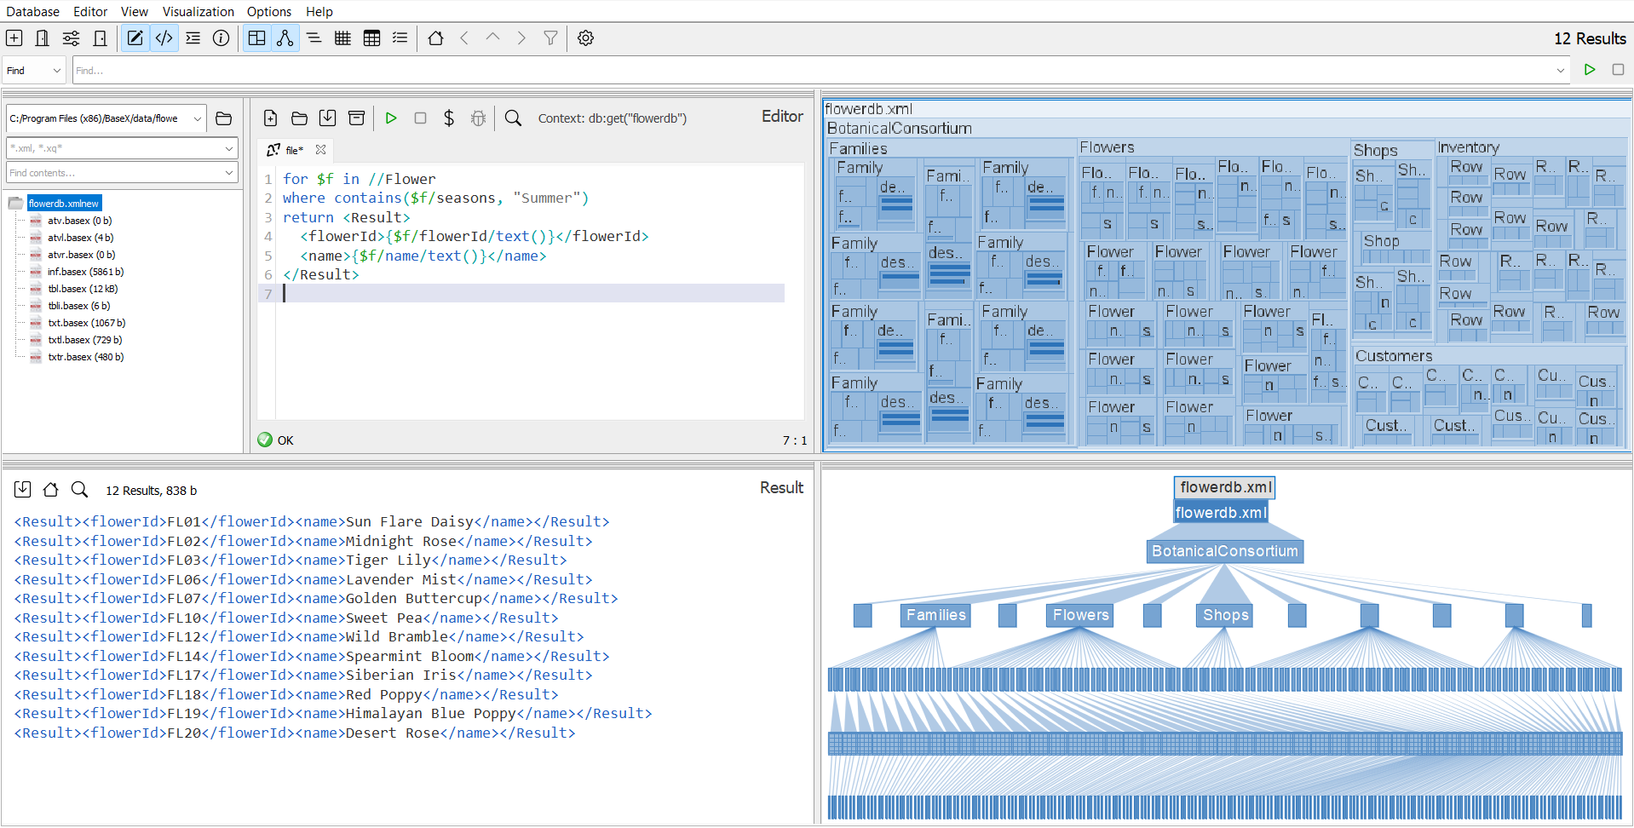
Results:
<Result><flowerId>FL01</flowerId><name>Sun Flare Daisy</name></Result>
<Result><flowerId>FL02</flowerId><name>Midnight Rose</name></Result>
<Result><flowerId>FL03</flowerId><name>Tiger Lily</name></Result>
<Result><flowerId>FL06</flowerId><name>Lavender Mist</name></Result>
<Result><flowerId>FL07</flowerId><name>Golden Buttercup</name></Result>
<Result><flowerId>FL10</flowerId><name>Sweet Pea</name></Result>
<Result><flowerId>FL12</flowerId><name>Wild Bramble</name></Result>
<Result><flowerId>FL14</flowerId><name>Spearmint Bloom</name></Result>
<Result><flowerId>FL17</flowerId><name>Siberian Iris</name></Result>
<Result><flowerId>FL18</flowerId><name>Red Poppy</name></Result>
<Result><flowerId>FL19</flowerId><name>Himalayan Blue Poppy</name></Result>
<Result><flowerId>FL20</flowerId><name>Desert Rose</name></Result>
- Customers in the same city as shop locations
Code:
for $c in //Customer
for $s in //Shop
where $c/city = $s/city
return <Result>
<customerId>{$c/customerId/text()}</customerId>
<name>{$c/name/text()}</name>
<city>{$c/city/text()}</city>
</Result>
Screenshot:
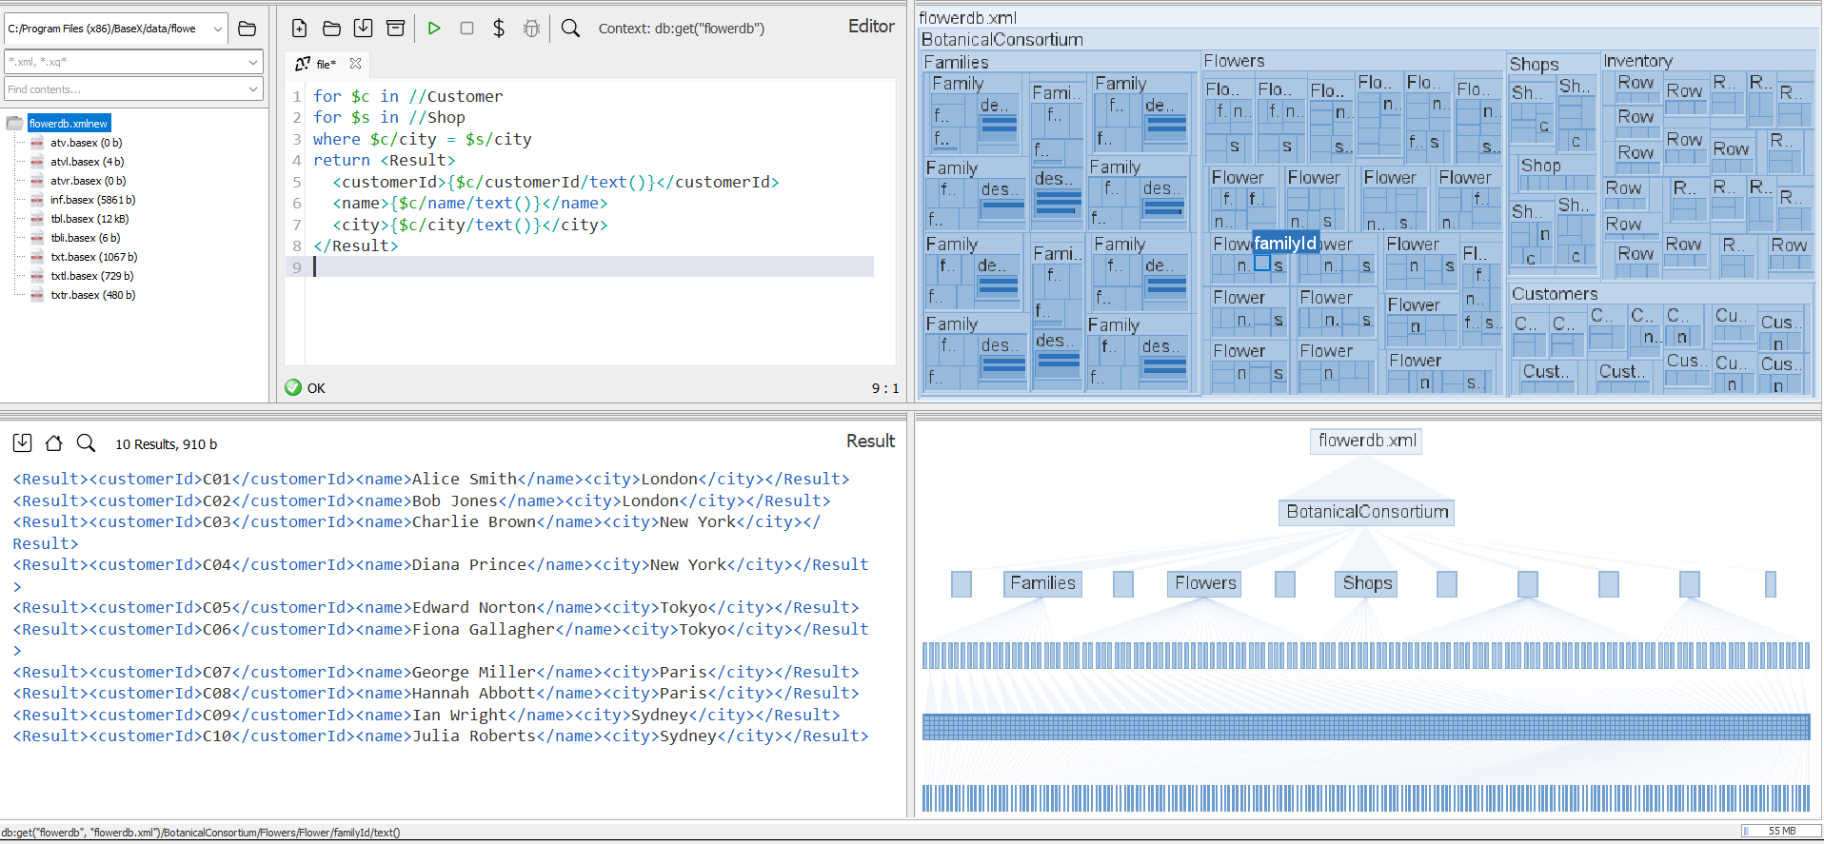
Results:
<Result><customerId>C01</customerId><name>Alice Smith</name><city>London</city></Result>
<Result><customerId>C02</customerId><name>Bob Jones</name><city>London</city></Result>
<Result><customerId>C03</customerId><name>Charlie Brown</name><city>New York</city></Result>
<Result><customerId>C04</customerId><name>Diana Prince</name><city>New York</city></Result>
<Result><customerId>C05</customerId><name>Edward Norton</name><city>Tokyo</city></Result>
<Result><customerId>C06</customerId><name>Fiona Gallagher</name><city>Tokyo</city></Result>
<Result><customerId>C07</customerId><name>George Miller</name><city>Paris</city></Result>
<Result><customerId>C08</customerId><name>Hannah Abbott</name><city>Paris</city></Result>
<Result><customerId>C09</customerId><name>Ian Wright</name><city>Sydney</city></Result>
<Result><customerId>C10</customerId><name>Julia Roberts</name><city>Sydney</city></Result>
- Flowers that are never stocked in any shop
Code:
let $stockedIds := //Inventory/Row/flowerId
for $f in //Flower
where not($f/flowerId = $stockedIds)
return <Result>
<flowerId>{$f/flowerId/text()}</flowerId>
<name>{$f/name/text()}</name>
</Result>
Screenshot:
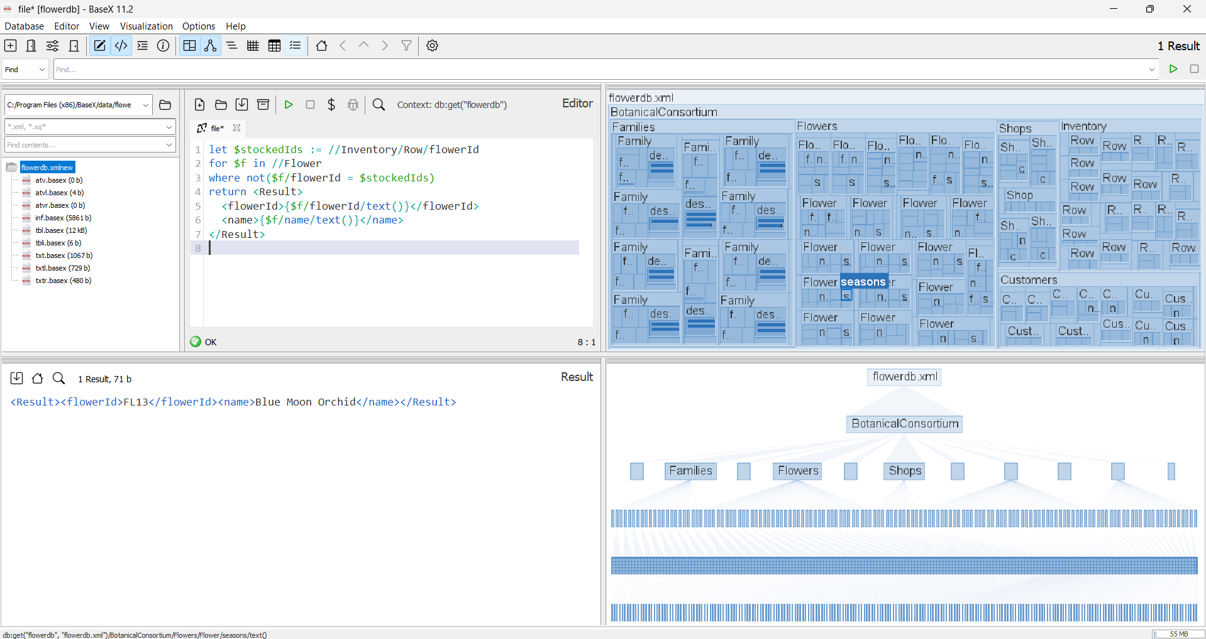
Results:
<Result><flowerId>FL13</flowerId><name>Blue Moon Orchid</name></Result>

Aggregation/ Grouping:
- Flowers that bloom in spring but are not in the Asteracea family
Code:
for $f in //Flower
for $fam in //Family
where $f/familyId = $fam/familyId
and contains($f/seasons, "Spring")
and $fam/familyName != "Asteraceae"
return <Result>
<flowerId>{$f/flowerId/text()}</flowerId>
<name>{$f/name/text()}</name>
<familyName>{$fam/familyName/text()}</familyName>
</Result>
Screenshot:
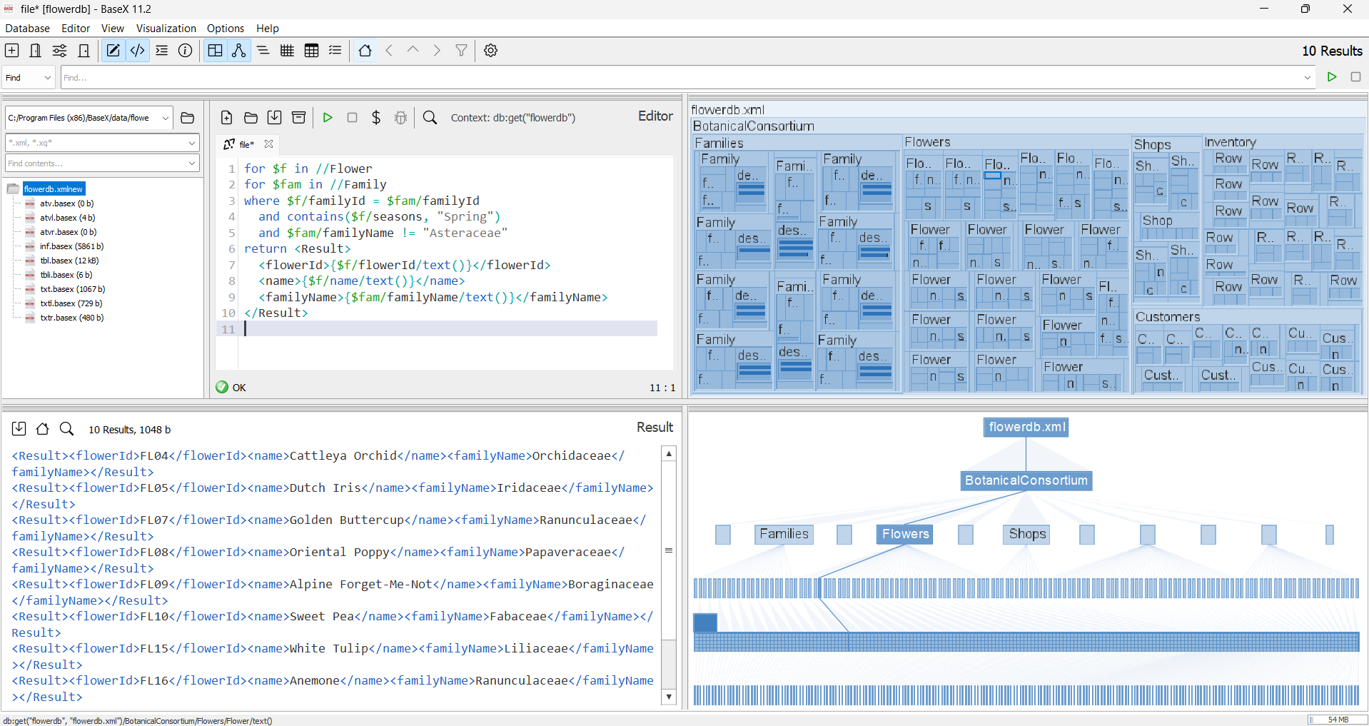
Results:
<Result><flowerId>FL04</flowerId><name>Cattleya Orchid</name><familyName>Orchidaceae</familyName></Result>
<Result><flowerId>FL05</flowerId><name>Dutch Iris</name><familyName>Iridaceae</familyName></Result>
<Result><flowerId>FL07</flowerId><name>Golden Buttercup</name><familyName>Ranunculaceae</familyName></Result>
<Result><flowerId>FL08</flowerId><name>Oriental Poppy</name><familyName>Papaveraceae</familyName></Result>
<Result><flowerId>FL09</flowerId><name>Alpine Forget-Me-Not</name><familyName>Boraginaceae</familyName></Result>
<Result><flowerId>FL10</flowerId><name>Sweet Pea</name><familyName>Fabaceae</familyName></Result>
<Result><flowerId>FL15</flowerId><name>White Tulip</name><familyName>Liliaceae</familyName></Result>
<Result><flowerId>FL16</flowerId><name>Anemone</name><familyName>Ranunculaceae</familyName></Result>
<Result><flowerId>FL17</flowerId><name>Siberian Iris</name><familyName>Iridaceae</familyName></Result>
<Result><flowerId>FL20</flowerId><name>Desert Rose</name><familyName>Rosaceae</familyName></Result>
- For each family, show its name and the total stock quantity across all shops.
Code:
for $fam in //Family
let $flowersInFam := //Flower[familyId = $fam/familyId]/flowerId
let $total := sum(//Inventory/Row[flowerId = $flowersInFam]/stock)
return <Result>
<familyName>{$fam/familyName/text()}</familyName>
<totalStock>{$total}</totalStock>
</Result>
Screenshot:
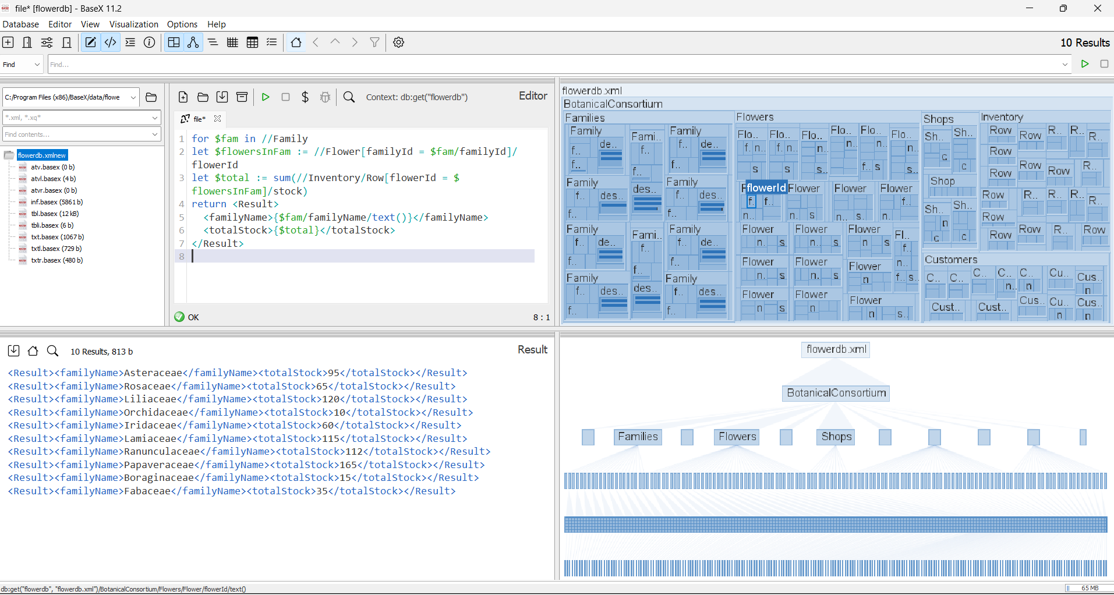
Results:
<Result><familyName>Asteraceae</familyName><totalStock>95</totalStock></Result>
<Result><familyName>Rosaceae</familyName><totalStock>65</totalStock></Result>
<Result><familyName>Liliaceae</familyName><totalStock>120</totalStock></Result>
<Result><familyName>Orchidaceae</familyName><totalStock>10</totalStock></Result>
<Result><familyName>Iridaceae</familyName><totalStock>60</totalStock></Result>
<Result><familyName>Lamiaceae</familyName><totalStock>115</totalStock></Result>
<Result><familyName>Ranunculaceae</familyName><totalStock>112</totalStock></Result>
<Result><familyName>Papaveraceae</familyName><totalStock>165</totalStock></Result>
<Result><familyName>Boraginaceae</familyName><totalStock>15</totalStock></Result>
<Result><familyName>Fabaceae</familyName><totalStock>35</totalStock></Result>

XML element/path design choices:
For this assignment I designed the XML file to have different sections that are linked together using IDs. There are also parent tags for Families, Flowers, and Shops to keep the data organized and avoid repetition. Instead of writing the family description beside every flower listed, I used familyID to connect the flower to its specific group description. I also used an inventory section that uses a row format to show which ships have which flowers available. When it comes to location I used cities world wide to make it easy to spot the same city between customers and shops; however for real world applications, if this is being done by a company in Ontario, the shops and customers would be within the province. Being more local allows more market segmentation research as you can look at the demographics of specific neighbourhoods, cities. The global locations may still do that but are open to a much larger population size and that creates more variance in the data.

Privacy Risks/ Mitigation:
The XML file poses a risk to the customer’s privacy in terms of their name being on the file. To mitigate this from being shared with other unauthorized users, they can remove the names from the customer table and just go based on customerID which still gives each customer a unique identifier without having their names. The XML file also lists where people live , which is another privacy risk. To fix this, the operational team can remove the city names or even make the location more broad such as province/state/country.Another way to protect the customer’s privacy is by controlling who has access to the system, and even restricting who has access to the customers names and location to make sure only those who need the information can access it.

